Activity No .
Title of the Event | Marketing Club Event  “ Brand War” | 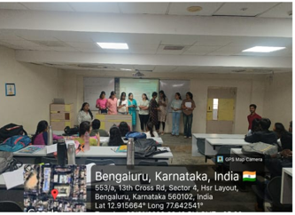
Day and Date | 6 January 2026
Venue (With all details ) | Room No-309
In collaboration with ( if any) | -
Details of Resource Person With Designation | Dr.Veto Dey | 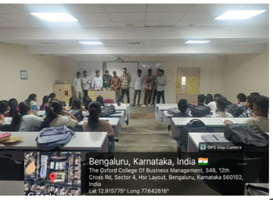
Organizing Department/Coordinators | Business Mnagement, Dr.Veto Dey
Course and semester | MBA I Sem
No of Students & Faculty Participants | 45

Coordinator HoD Vice-Principal Principal

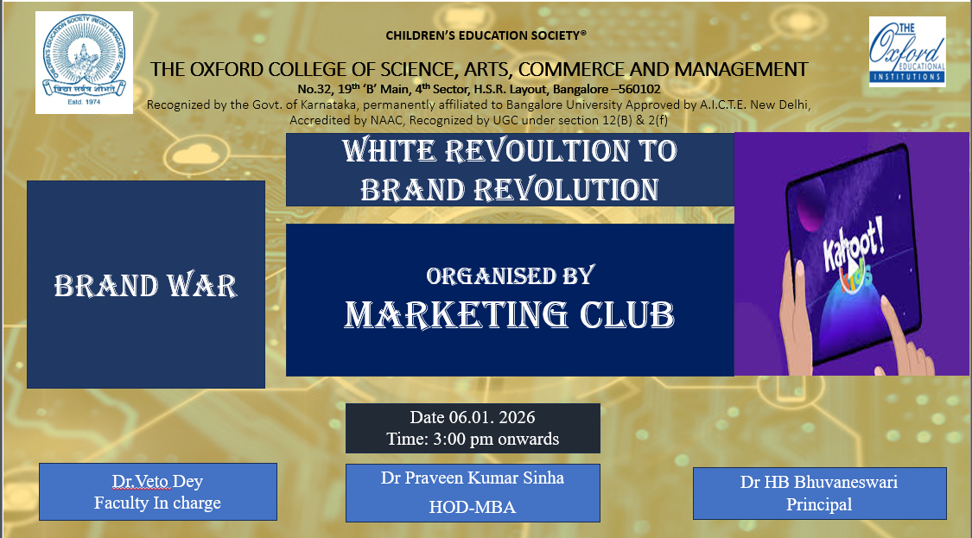
Introduction
In today’s competitive marketplace, understanding brand competition and positioning is vital for management students. To enhance practical exposure to brand rivalry and competitive marketing strategies, the Department of MBA organized an activity titled “Brand War” under the Marketing Club. The activity focused on experiential learning through real-world brand comparisons.
Description of the Activity
The Brand War activity was conducted on 6 January 2026 during the Marketing Club hour for MBA Semester I students. Students were divided into teams and assigned competing brands from the same product category. Each team analyzed brands based on positioning, target market, pricing, promotion, product features, and differentiation. Teams presented arguments supporting their brand, followed by interactive discussions and rebuttals, with faculty members moderating and linking theory to practice.
Outcome of the Activity
The activity enhanced students’ understanding of competitive branding and market positioning. It helped develop analytical thinking, communication skills, teamwork, and strategic decision-making. Active participation reflected students’ enthusiasm and deeper engagement with marketing concepts.
Conclusion
The Brand War activity effectively bridged the gap between marketing theory and real-world application. It promoted critical thinking, collaborative learning, and practical understanding of branding strategies. The Department of MBA will continue organizing such activities to enhance student learning and industry readiness.

